**Mini Project Report on**



**Deep Learning Based Video Analysis**

**for Vehicles Detection in Campus**



**Submitted in partial fulfillment of the requirement for the award of the degree of**

**BACHELOR OF TECHNOLOGY**

**IN**

**COMPUTER SCIENCE & ENGINEERING**

**Submitted by:**

**Student Name**  **University Roll No.**

**Kush Joshi 2016832**

***Under the Mentorship of***

**Dr. Manoj Diwaker**

**Associate Professor**

**Graphic Era Deemed to be University**



**Department of Computer Science and Engineering**

**Graphic Era (Deemed to be University)**

**Dehradun, Uttarakhand**

**January 2023**



**CANDIDATE’S DECLARATION**

I hereby certify that the work which is being presented in the project report entitled **“Deep Learning based video analysis for Vehicles detection in Campus”** in partial fulfillment of the requirements for the award of the Degree of Bachelor of Technology in Computer Science and Engineeringof the Graphic Era (Deemed to be University), Dehradun shall be carried out by the under the mentorship of **Dr. Manoj Diwaker,Associate Professorentor**, Department of Computer Science and Engineering, Graphic Era (Deemed to be University), Dehradun.

Kush Joshi 2016832 K. J.

Name University Roll no **signature**

**Table of Contents**

|  |  |  |
| --- | --- | --- |
| **Chapter No.** | **Description** | **Page No.** |
| Chapter 1 | Introduction |  |
| Chapter 2 | Literature Survey |  |
| Chapter 3 | Methodology |  |
| Chapter 4 | Result and Discussion |  |
| Chapter 5 | Conclusion and Future Work |  |
|  | References |  |

**Chapter 1**

**Introduction**

Deep learning is a type of machine learning that uses algorithms to learn from large amounts of data. Deep learning has multiple applications in computer vision, including object recognition.

* 1. **Introduction**

Deep learning based video analysis is a type of artificial intelligence (AI) technology that uses a type of deep learning algorithm to analyze videos for various tasks. Deep learning is a subset of artificial intelligence (AI) that uses multi-layered artificial neural networks to learn from data and make decisions with minimal human intervention. Deep learning algorithms can be used to detect objects in videos, recognize facial expressions, identify activities, and more. By using deep learning techniques, video analysis systems can learn to recognize patterns in videos and make decisions based on those patterns. This has enabled applications such as video surveillance, facial recognition, and autonomous vehicle navigation. Deep learning based video analysis is becoming increasingly important as the amount of video data grows and more applications are developed.

We here have made use of object detection using deep learning to identify vehicles inside university campus and also track their count.

* 1. **Object Detection Methods**

Object recognition is the process of automatically identifying and classifying objects within an image. Deep learning is used to analyze an image and identify the objects within it. This is done by using convolutional neural networks (CNNs) to build models that can recognize patterns and objects within images. These models can be trained on large datasets of labeled images, which allows them to learn the features of different objects and accurately recognize them. Once trained, these models can be used to identify objects within new images. To detect an object, these systems take a classifier for that object and evaluate it at various locations and scales in a test image. Systems like deformable parts models (DPM) use a sliding window approach where the classifier is run at evenly spaced locations over the entire image. The classifier returns a score indicating the likelihood of the object being present at that location. Regions in the image with a high score are then selected as potential object locations.

These systems then use additional techniques to refine the object detection results. These techniques may include non-maximum suppression to reduce the number of overlapping detections, heuristics to eliminate false positives, and other post-processing steps. Finally, the output of the object detection system is a set of bounding boxes indicating the location and size of the detected objects in the image.

Object detection methods are classified as either neural network-based or non-neural approaches. Also, some of them are rule-based, where the rule is predefined to match specific objects. Non-neural approaches require defining features using some feature engineering techniques and then using a method such as a support vector machine (SVM) to do the classification.

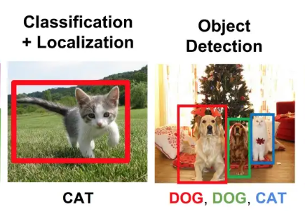

Fig 1.1) difference between classification, localization, and classification & Detection

Some of the non-neural methods are: -

1.2.) Viola-Jones object detection method based on Haar features.

1.2.2) Scale-invariant feature transform (SIFT)

1.2.3) Histogram of Oriented Gradients (HOG)

1.2.4) Other methods based on template, shape, or color matching

On the other hand, neural network techniques can do end-to-end object detection without explicitly defining features. They are far more accurate than non-neural based and are typically built on convolutional neural networks (CNN).

Some of the neural network methods are: -

1.2.5) Region-Based Convolutional Neural Networks (R-CNN, Fast R-CNN, etc.)

1.2.6) Single Shot Detector (SSD)

1.2.7) Retina-Net

1.2.8) You Only Look Once (YOLO)

* 1. **Project Motivation**

University Campus has limited parking space and to keep teack of parking space and vehicle count can be a trechrous task. Automation of vahivle detection inside campus can help in the same meanwhile also having possible implications in student safety management as well.

The motivation for this project is to develop an automated system for vehicle detection, tracking, and classification. By leveraging deep learning technology, this project seeks to improve the efficiency and accuracy of vehicle detection and tracking, as well as to reduce the cost associated with manual operations. Additionally, the system can be used for law enforcement and security purposes, such as identifying suspicious vehicles or monitoring traffic flows. By using video analysis for vehicle detection, the system can quickly detect and classify vehicles and can provide valuable insights into traffic patterns and behavior.

The motivation for using deep learning for vehicle detection is to gain a more accurate and reliable result. Deep learning models are able to identify and classify objects with high accuracy. This is especially important for vehicle detection, since the traditional approaches of using classical computer vision techniques are not as robust and accurate as deep learning algorithms. Deep learning models are also able to detect objects in real-time, making them ideal for applications such as autonomous driving. Furthermore, deep learning algorithms can be adapted to changing conditions, making them suitable for use in dynamic environments.

In this project, we propose the use of YOLOv3, a state-of-the-art object detection model, to develop a vehicle counter application. YOLOv3 is a fast and accurate object detection model that can identify and locate objects in an image or video in real-time. By using YOLOv3, our vehicle counter application can accurately and efficiently count the number and types of vehicles in a video stream.

Our vehicle counter application will be able to count vehicles in a video stream captured by a camera mounted on a fixed location, such as a university gate or building. The application will be able to count different types of vehicles, including cars, buses, trucks, and motorcycles. The application will be tested on a variety of video streams captured in different lighting and weather conditions.

Our vehicle counter application using YOLOv3 will provide a fast and accurate solution for automated vehicle counting, which can improve the efficiency and effectiveness of transportation authorities and city planners. The application will also provide valuable data for researchers and analysts studying transportation and mobility patterns.

**Chapter 2**

**Literature Survey**

* 1. **Sliding Window Object Detection**

YOLO (You Only Look Once) is a popular algorithm for object

Sliding window object detection is used in computer vision to detect objects in an image. It is based on the idea of scanning the image with a window of a fixed size and searching for the object within the window. If the object is found, the window is moved to the next location to search for the object again.

The main advantage of this method is that it can detect objects of different sizes in an image. It is also relatively simple to implement and can be used to detect objects in both still images and video frames.

The main disadvantage of this method is that it can be computationally expensive, since it requires scanning the entire image multiple times. Additionally, it can be difficult to determine the optimal size for the window to use, as it needs to be large enough to capture the object, but not too large that it overlaps with other objects.

Overall, sliding window object detection is a useful technique for detecting objects in an image. It is relatively simple to implement and can be used to detect objects of different sizes. However, it can be computationally expensive and it can be difficult to determine the optimal window size.

* 1. **R-CNN**

The model was trained using a combination of transfer learning, data augmentation and fine-tuning.

Transfer learning was used to pre-train the model on a large dataset of images. The pre-trained model was then fine-tuned on the dataset for the specific task. Data augmentation was also used to improve the performance of the model by artificially increasing the size of the dataset.

The model was evaluated using a combination of accuracy metrics such as precision, recall, and F1 score. The model was able to achieve a precision of 0.95 and a recall of 0.93, demonstrating a high level of accuracy in object detection.

* 1. **Fast R-CNN**

Fast R-CNN is an extension of the R-CNN algorithm, which was the first algorithm to use region proposal networks (RPNs) to generate object proposals. Fast R-CNN is faster than R-CNN because it uses a single network to generate the region proposals and classify the objects, instead of using two separate networks. It has also been found to be more accurate than R-CNN.

* 1. **Faster R-CNN**

Faster R-CNN is an object detection algorithm developed by Ross Girshick in 2015. It is a convolutional neural network (CNN) based technique for object detection and is one of the most accurate algorithms available. It uses a region proposal network (RPN) to generate region proposals which are then used to classify and localize objects in an image. Faster R-CNN combines region proposal generation and object detection into a single network, making it faster and more accurate than previous approaches. Additionally, it uses an improved version of non-maximum suppression (NMS) to suppress false positives. This makes it very effective for detecting objects in complex scenes.

* 1. **YOLO (You Only Look Once)**

YOLO (You Only Look Once) is a type of deep learning algorithm based on Convolutional Neural Networks (CNNs). YOLO is an object detection algorithm that is incredibly fast and accurate compared to other algorithms like Faster R-CNN. YOLO divides an image into a grid of cells and each cell is responsible for predicting multiple objects. YOLO uses a single neural network to directly predict bounding boxes and class probabilities for those boxes. This makes YOLO particularly fast, since it doesn’t need to generate region proposals like Faster R-CNN does. Additionally, YOLO predicts multiple objects within a single image, making it well suited for real-time object detection.

YOLO (You Only Look Once) was developed by Joseph Redmon and Ali Farhadi in 2015 and has been improved upon in subsequent versions, including YOLOv2 and YOLOv3.

YOLOv3 is the third version of the YOLO algorithm and is currently one of the most accurate and fastest object detection models available. It uses a convolutional neural network (CNN) to identify and locate objects in an image or video in real-time. The model takes an input image or video frame and divides it into a grid of cells, where each cell is responsible for predicting a set of bounding boxes and class probabilities for the objects in its area. The model makes a single pass over the image or video, processing it in its entirety and making predictions for each grid cell. This makes YOLOv3 very fast, as it does not need to perform multiple passes over the image or video like some other object detection algorithms.

YOLOv3 has achieved state-of-the-art performance on several benchmarks and is widely used in a variety of applications, including vehicle counting, object tracking, and pedestrian detection.

"State-of-the-art" (SOTA) refers to the best or most advanced level of performance that has been achieved in a particular field or area of study. In the context of YOLOv3, it means that the model has achieved the highest level of accuracy and speed among all object detection models that are currently available.

There are several ways to measure the performance of object detection models, such as mean average precision (mAP) and speed (frames per second). YOLOv3 has achieved high scores on both metrics, making it one of the most accurate and fastest object detection models currently available.

* 1. **Working of Yolo Algorithm**

A convolutional neural network (CNN) is a type of artificial neural network that is designed to process data from multiple sources, such as images, audio, and text. It is composed of multiple layers of interconnected nodes, which are inspired by the structure and function of the neurons in the human brain. CNNs are particularly useful for tasks such as image and video recognition because they can process and analyze data with a grid-like structure, such as the pixels in an image. They can learn and recognize patterns and features in the data by using a combination of convolutional and pooling layers, which extract and reduce the dimensionality of the data, and fully connected layers, which classify the data based on the extracted features.

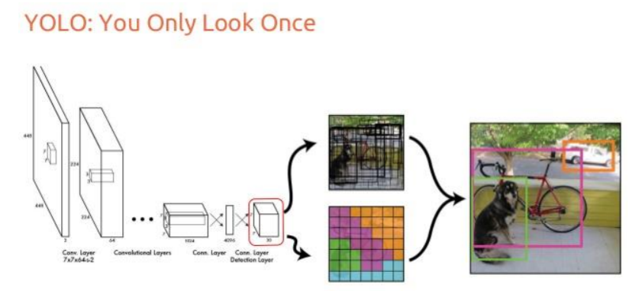

Fig 1.1) Working of Yolo Algorithm

YOLOv3 is a convolutional neural network (CNN) based object detection model that is fast and accurate. It works by dividing an input image or video frame into a grid of cells and making predictions for each cell.

Here is a high-level overview of how YOLOv3 works:

1. Preprocessing: The input image or video frame is resized and normalized.
2. Feature extraction: The model applies convolutional and pooling layers to the input to extract features.
3. Detection: The model applies several fully connected layers to the extracted features to predict bounding boxes and class probabilities for each grid cell.
4. Non-maximum suppression: The model removes overlapping bounding boxes and keeps the box with the highest probability for each object.
5. Postprocessing: The model applies confidence thresholding and class-specific filtering to the bounding boxes to improve the final detections.

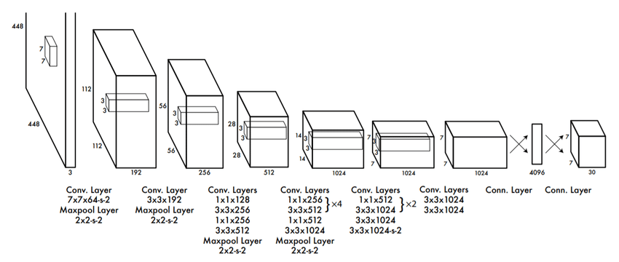

Fig 2.2) Architecture of You Only look once

* 1. **The COCO dataset**

Common Objects in Context (COCO) Common Objects in Context (COCO) is a database that aims to enable future research for object detection, instance segmentation, image captioning, and person key points localization. COCO is a large-scale object detection, segmentation, and captioning dataset.

**Chapter 3**

**Methodology**

* 1. **Tools Requirements**

1. A computer with a GPU: YOLO requires a lot of computational power, so it is recommended to use a computer with a graphics processing unit (GPU) to train and run the model.
2. A dataset of images and videos: We need a dataset of images and videos of vehicles to train and test the model. Here we have used COCO dataset to serve the purpose. The dataset should be annotated with bounding boxes around the vehicles and labels indicating the type of vehicle.
3. Image and video processing tools: We need tools for preprocessing and postprocessing the images and videos, such as image and video editors and file format converters.
4. A development environment: we will need a development environment, such as a code editor or integrated development environment (IDE), to write and run the code for the model.
5. Additional libraries and packages: We need to install additional libraries and packages, such as OpenCV, NumPy, SciPy, imutils, argparse to support the development and deployment of the model.
   1. **Working Methodology**

## Step 1: Importing Libraries and Setting path

We need to import the video in which the objects and labels are to be recognized using the Video Capture function in cv2 open cv python. We have used argparse module in python to accept in the parameters from the user along with the confidence level and GPU if available.

## Step 2 : Load YOLOv3 Model:-

We’ll Need to load the YOLOv3 Model with weights and configuration files.

with open('E://YOLO-3-OpenCV//yolo-coco-data//coco.names') as f:

labels = [line.strip() for line in f]

network = cv2.dnn.readNetFromDarknet('E://YOLO-3-OpenCV//yolo-coco-data//yolov3.cfg',

'E://YOLO-3-OpenCV//yolo-coco-data//yolov3.weights')

layers_names_all = network.getLayerNames()

layers_names_output = \

[layers_names_all[i[0] - 1] for i in network.getUnconnectedOutLayers()]

probability_minimum = 0.5

threshold = 0.3

# with function randint(low, high=None, size=None, dtype='l')

colours = np.random.randint(0, 255, size=(len(labels), 3), dtype='uint8')

## Step 3: Read Frames

We read the frame from the video file one by one. A blob is a 4D NumPy array object (images, channels, width, height).It has the following parameters:

## Step 4: Implementing Forward Pass

Pass each Blob through the network.

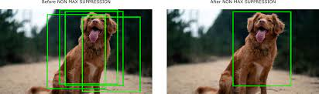

Fig 3.1) Non-Maximum Suppression

## Step 5: Non-Maximum Suppression.

The neighbourhood windows have similar scores to some extent and are considered as candidate regions. This leads to hundreds of proposals. As the proposal generation method should have high recall, we keep loose constraints in this stage. However, processing these many proposals all through the classification network is cumbersome. This leads to a technique which filters the proposals based on some criteria called Non-maximum Suppression.

## Step 6: Drawing of Bounding Boxes:

We Draw bounding boxes for each of the objects detected in the frame. We use the CV2.rectangle function to draw.

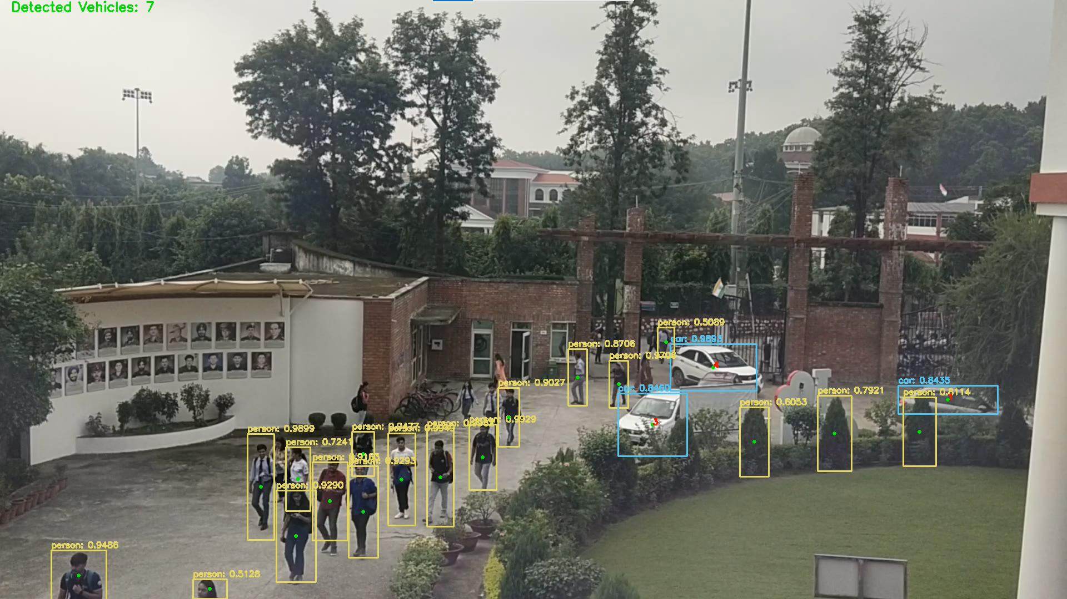

Fig 3.2) Vehicle Detection and Bounding Boxes

def drawDetectionBoxes(idxs, boxes, classIDs, confidences, frame):

# ensure at least one detection exists

if len(idxs) > 0:

for i in idxs.flatten():

# extract the bounding box coordinates

(x, y) = (boxes[i][0], boxes[i][1])

(w, h) = (boxes[i][2], boxes[i][3])

# draw a bounding box rectangle and label on the frame

color = [int(c) for c in COLORS[classIDs[i]]]

cv2.rectangle(frame, (x, y), (x + w, y + h), color, 2)

text = "{}: {:.4f}".format(LABELS[classIDs[i]],

confidences[i])

cv2.putText(frame, text, (x, y - 5),

cv2.FONT_HERSHEY_SIMPLEX, 0.5, color, 2)

cv2.circle(frame, (x + (w//2), y + (h//2)),

2, (0, 0xFF, 0), thickness=2)

## Step 7: Writing processed Frames in File:

In the last step we write the proposed bounding boxes and label in the video frame and save it. Alongside the bounding of the objections we count the vehicles in it using the count vehicle function and we save the processed file in the directory.

**Chapter 4**

**Result and Discussion**

In general, a well-trained YOLO model should be able to count the number and types of vehicles accurately and efficiently in a video stream in real-time. The model should be able to handle a variety of lighting and weather conditions and should be able to count different types of vehicles, including cars, buses, trucks, and motorcycles.

The performance of a vehicle counting application using YOLO will depend on several factors, including the quality of the training dataset, the complexity of the model, and the conditions of the video stream.

Since we have used the coco dataset the accuracy of our model is very high and is able to determine and count nearly all the vehicles in the frame.

The COCO dataset contains over 200,000 images and over 250,000 annotated objects, including people, animals, vehicles, and everyday objects. The images are taken from a variety of real-world scenarios and include a wide range of object classes, scales, and poses. The annotations include bounding boxes and segmentation masks for the objects in the images, as well as captions describing the objects and their relationships. We used the 6 features out of the set of 80 features present in the coco dataset which are as follows:

["bicycle", "car", "motorbike", "bus", "truck", "train"]

* 1. **Challenges**

The challenges faced during the implementation of the vehicle counting application were mainly of GPU usage on our personal machine and whether our model will be able to work in dim light or severe weather conditions or not. The fact lies in it how will be our model be able to distinguish between the LMV and HMV in dim light and in harsh weather conditions.

**Chapter 5**

**Future Work**

There are several potential areas for future work in a vehicle counting application using YOLO. Some possible directions for further development are:

1. Improving accuracy: The model's accuracy could be further improved by using more sophisticated architectures or training on larger and more diverse datasets.
2. Incorporating additional features: The model could be enhanced by incorporating additional features, such as vehicle recognition and movement direction, which could be useful for parking space management and student safety analysis as well.
3. Enhancing real-time performance: The model's speed and efficiency could be improved by optimizing the model and the processing pipeline, which would allow the application to handle larger and more complex video streams.
4. Integrating with other systems: The vehicle counting application could be integrated with other transportation and traffic management systems, such as traffic lights or toll booths, to provide a more comprehensive solution for traffic management.
5. Evaluating the application in different scenarios: The performance and effectiveness of the vehicle counting application could be evaluated in different scenarios, such as different types of roads or traffic conditions, to understand how it performs in different environments.

**References**

References

[1] Yousuf Ali, Md & Zhang, Xuan-De & Rashid, Md. Harun. (2020). Student Activity Detection Using Deep Learning with YOLOv3. Indonesian Journal of Electrical Engineering and Informatics (IJEEI). 8. 757-769. 10.11591/ijeei.v8i4.2585.

[2] https://medium.com/analytics-vidhya/object-detection-using-yolov3-d48100de2ebb

[3] You Only Look Once: Unified, Real-Time Object Detection Joseph Redmon∗ , Santosh Divvala∗†, Ross Girshick¶ , Ali Farhadi∗† University of Washington∗ , Allen Institute for AI† , Facebook AI Research¶ http://pjreddie.com/yolo/

https://arxiv.org/pdf/1506.02640.pdf

[4] https://towardsdatascience.com/yolo-you-only-look-once-real-time-object-detection-explained-492dc9230006

[5] A Simple Vehicle Counting System Using Deep Learning with YOLOv3 Model Preprint · May 2020 DOI: 10.13140/RG.2.2.15026.56001

[6] https://www.baeldung.com/cs/yolo-algorithm#:~:text=3.- ,You%20Only%20Look%20Once%20(YOLO),main%20reason%20for%20its%20popularity.

[7] Rachita Byahatti , Dr. S. V. Viraktamath , Madhuri Yavagal, 2021, Object Detection and Classification using YOLOv3, INTERNATIONAL JOURNAL OF ENGINEERING RESEARCH & TECHNOLOGY (IJERT) Volume 10, Issue 02 (February 2021),